

IML semester project

Dr Shoaib



June 9, 2021

Health Care Chat-Bot

Project for the 6th Semester Subject -> Machine Learning

Health Care Chat-Bot is a Healthcare Domain Chatbot to simulate the predictions of a General Physician.

# Project Members

Ali Haider (FA18-BCS-126-B)

Waqas Khalid (FA18-BCS-122-B)

Faizan Ali (FA18-BCS-106-B)

# Brief

Through chatbots one can communicate with text or voice interface and get reply through artificial intelligence

Typically, a chat bot will communicate with a real person.

Chat bots are used in applications such as

1. E-commerce customer service,

2. Call centres,

3. Internet gaming.

Chatbots are programs built to automatically engage with received messages. Chatbots can be programmed to respond the same way each time, to respond differently to messages containing certain keywords and even to use machine learning to adapt their responses to fit the situation.

A developing number of hospitals, nursing homes, and even private centres, presently utilize online Chatbots for human services on their sites. These bots connect with potential patients visiting the site, helping them discover specialists, booking their appointments, and getting them access to the correct treatment.

In any case, the utilization of artificial intelligence in an industry where individuals’ lives could be in question, still starts misgivings in individuals. It brings up issues about whether the task mentioned above ought to be assigned to human staff. This healthcare chatbot system will help hospitals to provide healthcare support online 24 x 7, it answers deep as well as general questions. It also helps to generate leads and automatically delivers the information of leads to sales. By asking the questions in series it helps patients by guiding what exactly he/she is looking for.

# Features

- Register Screen.

- Sign-in Screen.

- Generates database for user login system.

- Offers you a GUI Based Chatbot for patients for diagnosing. [A pragmatic Approach for Diagnosis]

- Recommends an appropriate doctor to you for the following symptom.

# Algo

Decision Tree Classifier

# Efficiency

Efficiency or calculation time is different according to the disease and their symptoms.

It can vary case to case and also depends upon the symptoms sometime the patient it self not sure about symptoms or disease so that’s why we can not hardly say that.

# Modules Used

Our program uses a number of python modules to work properly:

1. tkinter
2. os
3. webbrowser
4. numpy
5. pandas
6. matplotlib

# Installation

Install the following package by typing the following in CMD

1. -pip install numpy
2. -pip install pandas
3. -pip install matplotlib

To make sure it is installed correctly, open IDLE and execute:

- import numpy

- import pandas

- import matplotlib

# Login/register

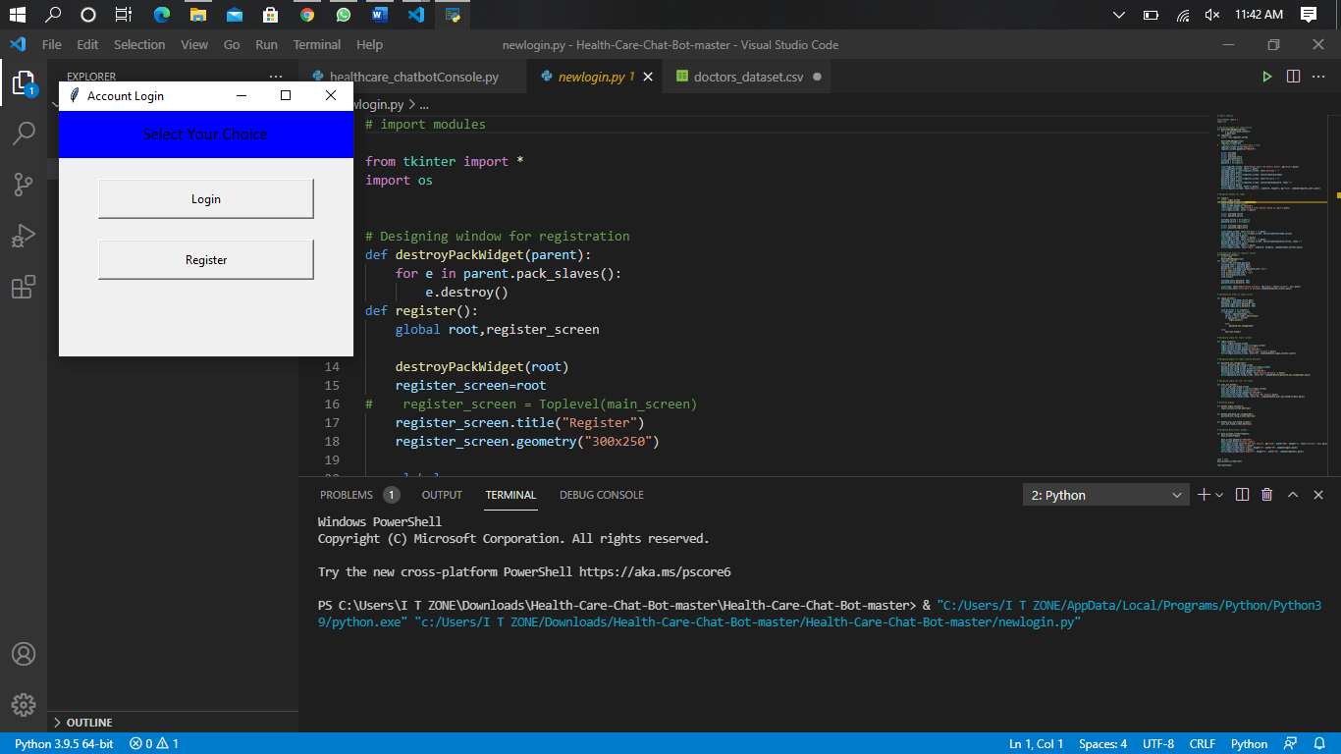

# Registration

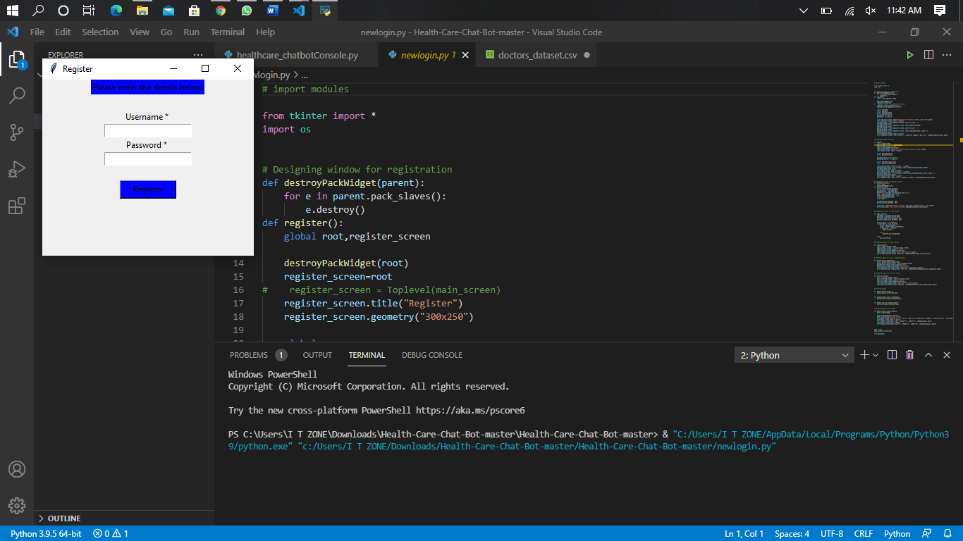

# Account login

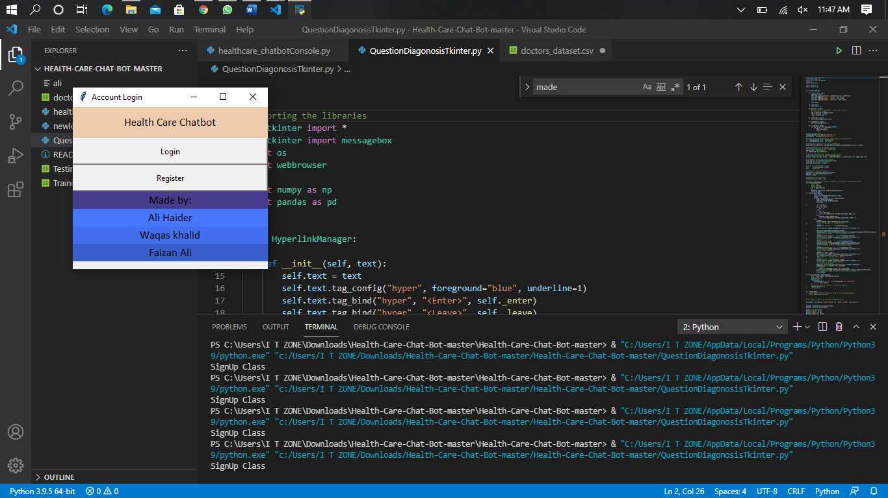

# Chat-bot interface/ Questions

1-

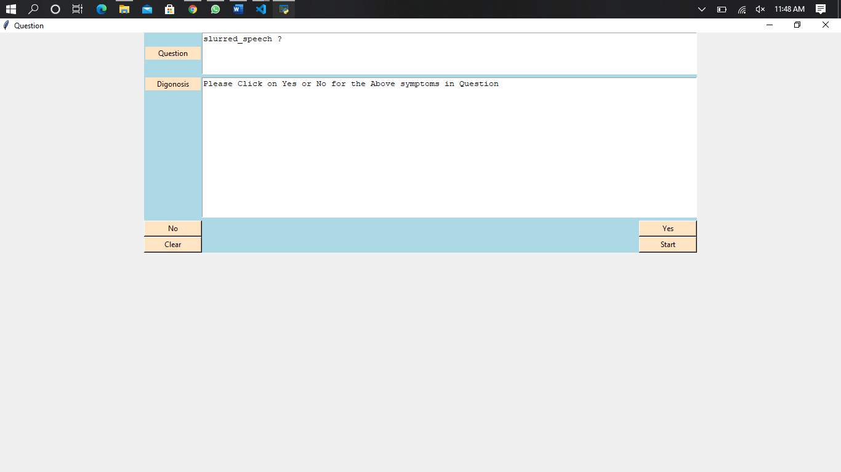

2-

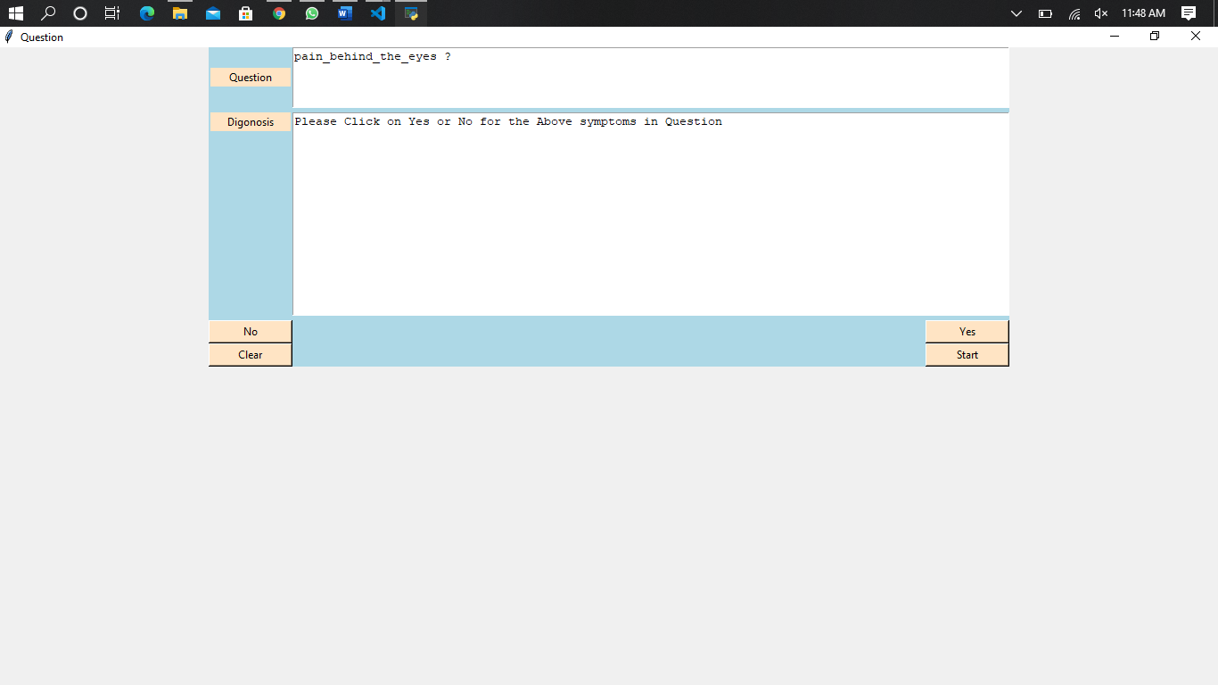

3-

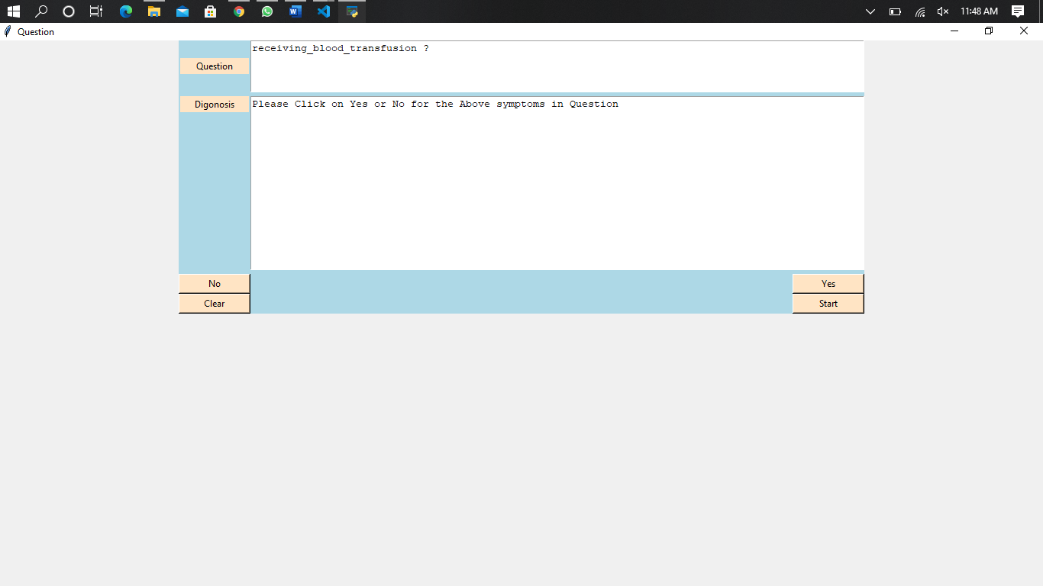

# Output

